<https://www.nasa.gov/centers/marshall/news/releases/2015/New-FIRST-Robotics-Regional-Competition-Coming-To-RocketCity.html>

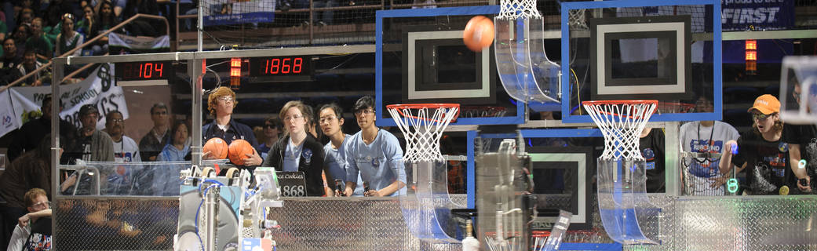

<http://www.engineering.com/Education/EducationArticles/ArticleID/6907/FIRST-Robotics-2014-Season-Begins--Aerial-Assist.aspx>

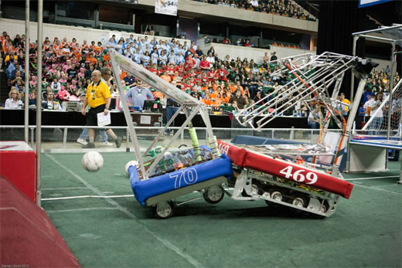

<http://www.pennlive.com/midstate/index.ssf/2013/02/area_high_school_student_robot.html>

